

**(An autonomous institution with A Grade by NAAC /UGC, Affiliated to Visvesvaraya Technological University, Belgaum, Approved by UGC/AICTE/Govt. of Karnataka)**

**Yelahanka, Bengaluru-560064**

# ACADEMIC YEAR 2020-2021



Submitted by

**GAURAV GHOSH & GROUP**

Submitted to

# "PRASHANTH.B.S"

Department of ISE



BIG DATA LAB

**NITTE MEENAKSHI INSTITUTE OF TECHNOLOGY**

**Yelahanka, Bengaluru-560064**

**PARTICIPANT’S**

* PAWAN KUMAR(1NT17IS121)
* GAURAV GHOSH(1NT17IS061)
* HARSHIT RAJ(1NT17IS068)
* SHUBHRA JYOTI(1NT17IS206)
* MANJUNATHA C(1NT17IS094)
* K CHETHANA PRASAD(1NT17IS076)
* ROUSHAN KUMAR(1NT16IS098)
* KEERTHI J(1NT17IS080)
* NAMRATHA N(1NT17IS104)
* HEMANTH V(1NT17IS070)
* M SHRAVAN(1NT17IS089)

**CERTIFICATE**

This is to certify that the Major Project report entitled Canteen Management System is submitted by Gaurav Ghosh & Group for the partial fulfillment of the requirement for the award of the degree of BACHELOR OF ENGINEERING in INFORMATION SCIENCE & ENGINEERING from NITTE MEENAKSHI INSTITUTE OF TECHNOLOGY Bengaluru(Yelahanka).

**ACKNOWLEDGEMENT**

We sincerely express indebtedness to esteemed and revered guide PRASHANTH B.S of Department of Information Science and Engineering for his invaluable guidance, supervision, and encouragement throughout the work. Without his kind patronage and guidance, the synopsis would not have taken shape.We owe sincere thanks to all the faculties in Department of Information Science and Engineering for their advice and counseling time to time.

**TABLE OF CONTENTS**

* ABSTRACT
* INTRODUCTION
* PURPOSE OF PROJECT
* PROJECT & PRODUCT OVERVIEWS
* HOW IT BENEFITS A CANTEEN
* HOW IT BENEFITS A CUSTOMER
* TEAM ARCHITECTURE
* Requirement gathering and planning
* Designing and Backend
* OVERALL DESCRIPTION
* PRODUCT PERSPECTIVE
* OBJECTIVE
* REQUIREMENTS
* External Interface Requirements
* Hardware Requirements
* Software Requirements
* DESIGN
* SOME SCREENSHOT OF OUR WEB-PAGE

**ABSTRACT**

The Project “Canteen Management System” enables the end users to register online, read and select the food from e-menu card and order food online by just selecting the food that the user want to have using android application. The results after selecting the food from the E-menu card will directly appear on the screen near the Chef who is going to cook the food for you. The system is the combination of Android as well as Web Application. By using this application the work of the waiter is reduced and we can also say that the work is nullified. The benefit of this is that if there is a rush in the Canteen then there will be chances that the waiters will be unavailable and the users can directly order the food to the chef online by using this application. The user will have a username and a password, by using which they can login into the system. This implies that the customer is the regular user of the Canteen. The manual system involves paperwork in the form of maintaining various files and manuals. Maintaining critical information in the files and manuals is full of risk and a tedious process. Including a framework showing how to apply Internet technology progressively as skills and confidence grow, the project demonstrates the route from adapting materials to developing an online environment. Nowadays people don’t have much time to spend in canteen by just there and waiting for the waiter to take their order. Many customers visit the canteen in their lunch break and recess so they have limited time to eat and return to their respective office and colleges. So this software helps them to save time and order food whenever they want without calling the waiter again and again.

**INTRODUCTION**

In today’s age of fast canteen management in the canteen, many canteens have chosen to focus on quick preparation and speedy delivery of orders. Until very recently, all of this delivery of orders were placed over the phone, but there are many disadvantages to this system, including the inconvenience of the customer needing to have a physical copy of the menu, lack of a visual confirmation that the order was placed correctly, and the necessity for the canteen to have an employee answering the phone and taking orders. The main advantage of an online ordering system is that it greatly simplifies the ordering process for both the customer and the canteen. When the customer visits the ordering web page, they are presented with an interactive and up-to-date menu, complete with all available options and adjusting prices based on the selected options. After making a selection, the item is then added to their order, which the customer can review the details at any time before checking out. This provides instant visual confirmation of what was selected. This system also greatly lightens the load on the canteen’s end, as the entire process of taking orders is automated. Once an order is placed on the web page, it is entered into the database and then retrieved, in pretty much real-time, by a web-based application on the canteen’s end. Within this application, all items in the order are displayed, along with their corresponding options and delivery details, in a concise and easy to read manner. This allows canteen employees to quickly go through the orders as they are placed and produce the necessary items with minimal delay and confusion.

**PURPOSE OF PROJECT**

Canteen Management System is the system where customers order their food and receive food in the canteen without any delay as they can directly go and collect what they ordered without waiting for a turn or waiting time. This system aims to accelerate customer orders and customer order system used by employees to accept customer order.

The purpose of the system is to develop a simple Canteen Management System and implement it, which later will be used for a web-based application.

The proposed “Canteen Management System” is economically feasible because:-

* The system requires very fewer time factors as compared to manual system.
* The system will provide fast and efficient automated environment instead of slow and error prone manual system, thus reducing both time and manpower spent in running the system.
* The system will have GUI interface and very less user training is required to learn it.

**PROJECT & PRODUCT OVERVIEWS**

A complete canteen management system makes canteen workers monitor overall day to day business analytics more accurately with an ease. It increases the presence of canteen fascinates core customers towards your food business leading to increased sales.

By bringing all necessities in one place canteen management system benefits both the user as well as the canteen owner smartly. Ultimately all business operation will be mad easier and single handed with the required inbuilt features.

The working of canteen management system is similar to an e-commerce website. Whenever your customers are busy with their work, instead of coming to your canteen they can just open your website, choose the menu they like and can simply order food.

As soon as order gets placed, you will be notified immediately, so that you can start order processing. One of the main advantages of canteen automation system is the order details are accurate when compared to the phone ordering system or manual system.

**HOW ITS BENEFITS A CANTEEN**

Canteen management system saves the canteen’s time by avoiding the food orders over the phone that has to be done manually. By making the ordering process fully automated, it increases the cost effectiveness and productivity of the canteen with a less manpower. In addition, it keeps you one step ahead of your competitors who don’t serve online.

Canteen management system even helps a casual dining canteen and provides an additional revenue source. It allows a canteen owner to easily update the online menu, food items etc and helps to stay in touch with the customers by offering discounts and targeted promotions. With a simplified management process, online ordering system makes it easy to handle multiple canteens from centralized application.

**HOW IT BENEFITS A CUSTOMER**

Now a day’s people are getting busy with their work, making the canteen online even saves customers time undoubtedly. Is allow them to order food online by creating a flexible ordering platform and serve them in time. The customer can select the food items from the online menu on the canteen website and can order accordingly as per their interest. In fact, they can place order the food orders within their budget by adding or removing the food items as per the cost variations.

This canteen automation system is useful for the canteen as well customer because canteen automation system save the time of the canteen's workers as well of the customers and as saves the manpower.

**TEAM ARCHITECTURE**

There were total 11 members in our project. The complete project is divided into two teams:-

**TEAM 1**

**REQUIREMENT GATHERING & PLANNING**

Planning identifies all deliverable services, describes the facilities, and defines the working to provide details about lab details to the faculties. This planning problem starts with a specification of user demand that is to be met by the production plan. For this context, the facilities provided to the user faculties are the major concern to be concentrated. This includes the easiest and efficient way to make them available an unoccupied lab. Consequently, all the fields must be kept while developing. Generally, a planning problem exists because there are limited production resources that cannot be stored from period to period. Choices must be made as to which resources to include and how to model their capacity and behavior, and their costs. Also, there may be uncertainty associated with the production function, such as uncertain yields or lead times. One might only include the most critical or limiting resource in the planning problem. Here comes the role of proper requirement gathering. If the requirements of the user are clear then it is quite easier for the developer to fulfill his all needs. As he can look into all the required resources, and with proper planning and cost estimation, he can achieve his software.

Thus, a proper planning and requirement gathering leads to an efficient software system.

**TEAM ARCHITECTURE**

**TEAM 2**

**DESIGNING AND BACKEND**

Designing is the most important and the most efficient function while software development. Without a proper design, it is very difficult to develop an appropriate software that fulfills nearly all user demands. Therefore, managing designing part in an organization is a critical activity. A designer needs to ensure that the design created by him can be easily understood by the all the members of developing a team. A proper design will allow the coder to implement the system development planning properly. Similarly, the backend part that includes the database management plays a key role in any of the systems. Thus, the team working on this field must know proper handling and management of database and its tools.

**OVERALL DESCRIPTION**

* **Time Saving:** Our canteen automation system is developed with a primary aim of 'Saving Time. The customer can order the food and it is also efficient for canteen workers because this system takes lesser time as compared to phone based or manually based system.
* **No Complication:** Major complication part for canteen automation system is adding a product or managing products section. In our canteen automation system, no complicated part is involved in managing sections; we have taken immense care in this section and nullified all complications which make this system accurate and unique.
* **Cost Effective:** It's cheaper. You don't have to purchase multiple copies of software to install on multiple computers. Multiple copies often require you to pay multiple licensing fees, but since you aren't actually purchasing any software with an online system, that's not a concern.
* **Security:** Online systems are just as secure. Most online canteen automation system programs allow you to create multiple user accounts with various levels of access. Your data is stored on secure, protected servers that feature firewalls and other online security programs.

**PRODUCT PERSPECTIVE**

The system will be developed using PHP, HTML, CSS,MONGODB,JAVASCRIPT and other Web tools like XAMPP server.

**Product Functions**

The product developed will provide an easy access to the user to manage and alter the canteen automation according to the need.

**General Constraints**

* The cost constraint includes ordering additional hardware to run the new system.
* No current web-site.
* Security must be upgraded for on-line searching.

**Assumptions**

* The system will support all browsers.
* The processor must be at least Dual cored and can be any other latest ones etc.

**OBJECTIVE**

Our objective is to make a platform independent application to maintain a database of all orders ordered from various sources and all the different services required by each of them. Established canteen automation practices should provide the needed connectivity and accountability between those two operational units, and when managed properly, enhances the effectiveness of both operations.

* Registration
* Order
* Payment
* Update

The above are the modules of canteen management system.

**REQUIREMENTS**

**EXTERNAL INTERFACE REQUIREMENTS**

The external system is to assume full responsibility for storage functions as well as warehouse management and warehouse control for an entire warehouse. The interfaces in this section are specified by documenting: the name and description of each scheme, source or input, destination or output, ranges, accuracy and tolerances, units of measure, timing, display formats, and organization, and data formats. The user interface required to be developed for the system should be user-friendly and attractive. The interface between the user and the system will be WIMP (Windows, Icons, Menu, Pointers) keeping in mind that the system is to be run through a web browser. All operations will be off point and click nature with all navigations performed through windows of the system specifically buttons and menus:

**Buttons:** The button is activated when the user will click on the left click of the mouse within the bounds of the button. And thus the action associated with it will be carried out.

**Menu:** All the operations will be arranged.

**REQUIREMENTS**

**HARDWARE REQUIREMENTS**

Here's what you Need to Use the canteen management system for online records:

* Minimum 20 GB HDD
* Minimum 256 MB RAM
* Pentium IV Processor
* **Input Devices:** Keyboard, Mouse
* **Output Devices:** Monitor, Printer

**SOFTWARE REQUIREMENTS**

* **Operating System:** Window XP and above
* **Browsers :** Chrome or any other latest web page supporting browser.
* XAMPP,LAMPP or any other similar server.

**DESIGN**

**USE CASE DIAGRAM**

A use case is a description of how end-users will use a software code. It describes a task or a series of tasks that users will accomplish using the software and includes the responses of the software to user actions.

**LOGIN PAGE USE CASE DIAGRAM**

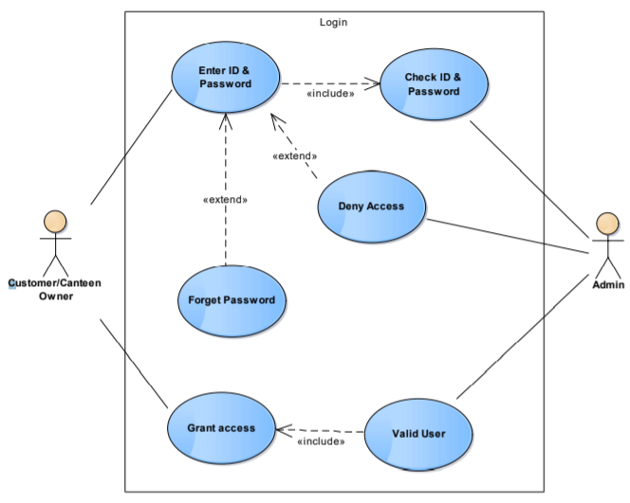

**REGISTRATION PAGE USE CASE DIAGRAM**

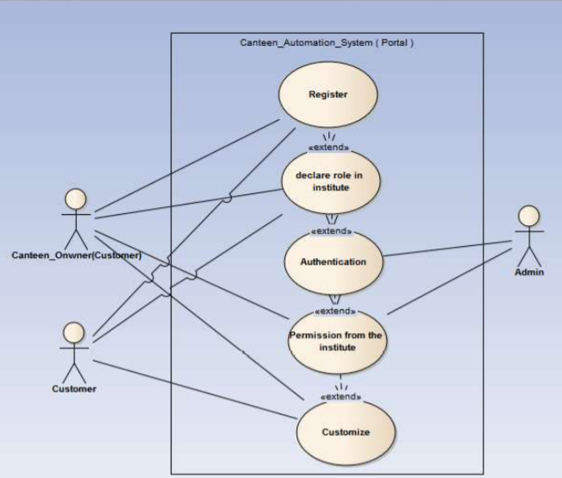

**ORDER , PAYMENT & UPDATE USE CASE DIAGRAM**

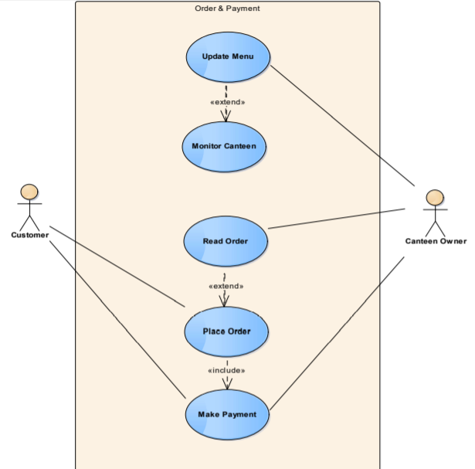

**SOME SCREENSHOT OF OUR WEBPAGE**

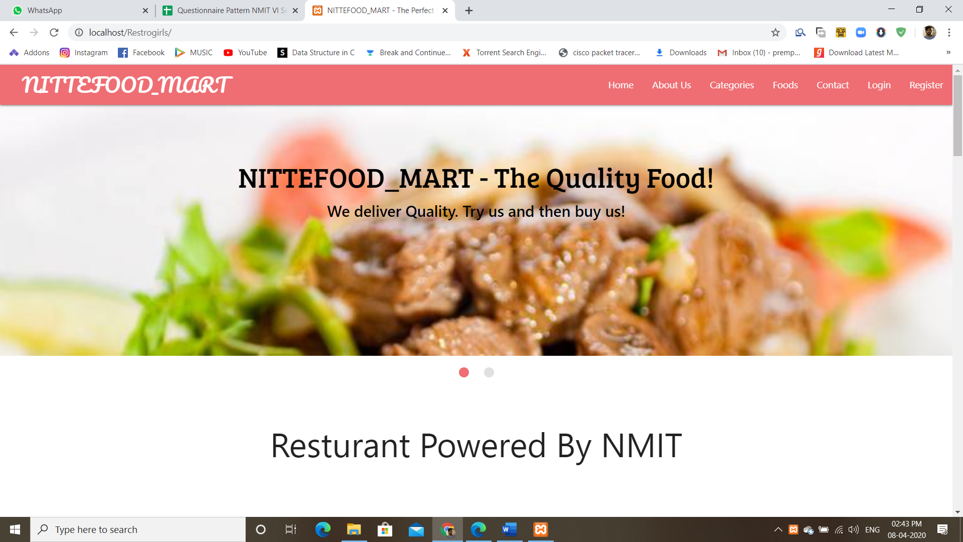

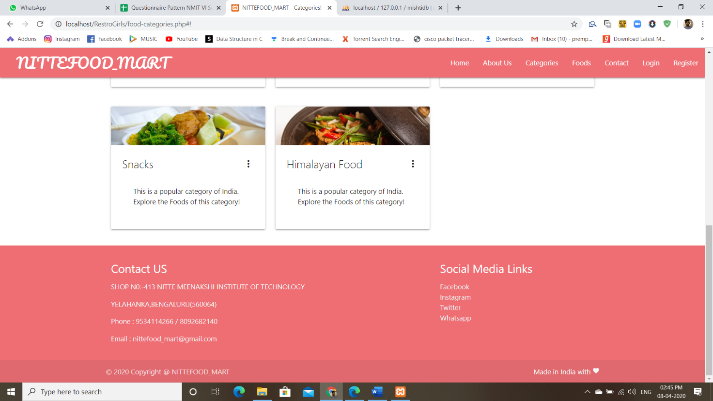

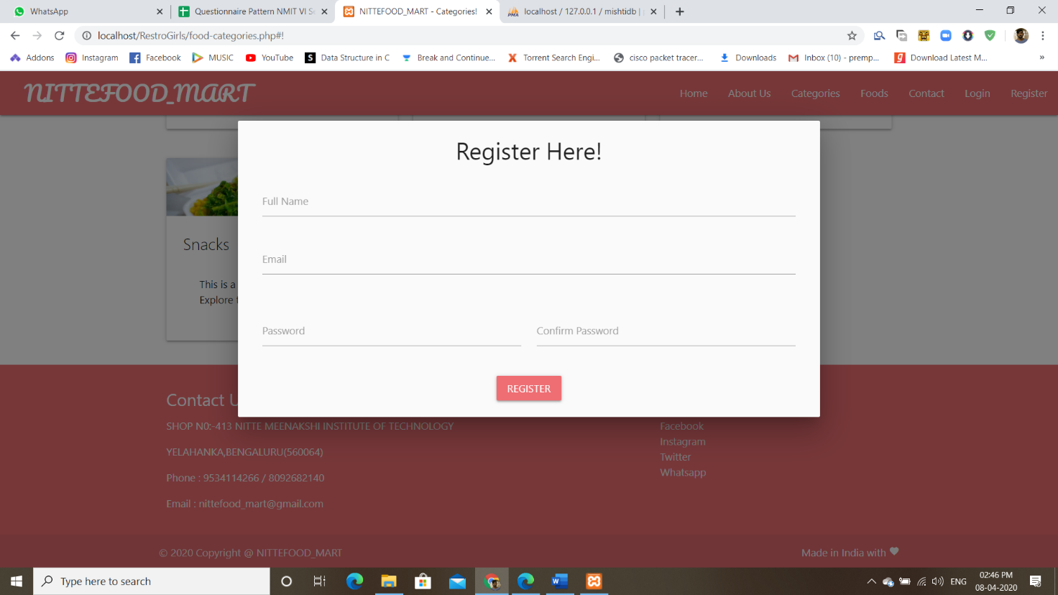

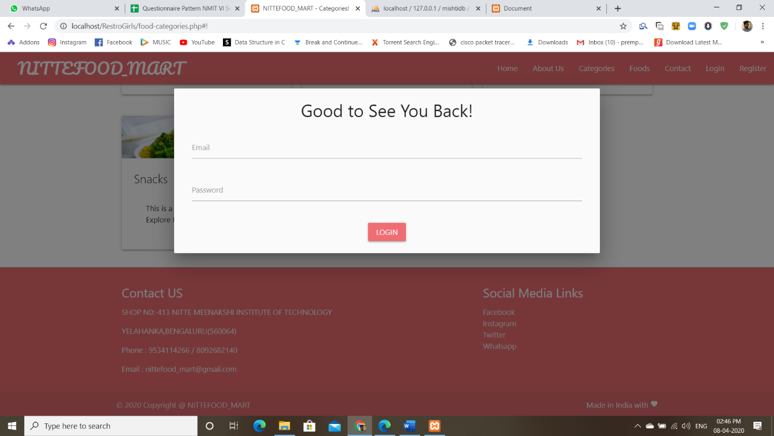

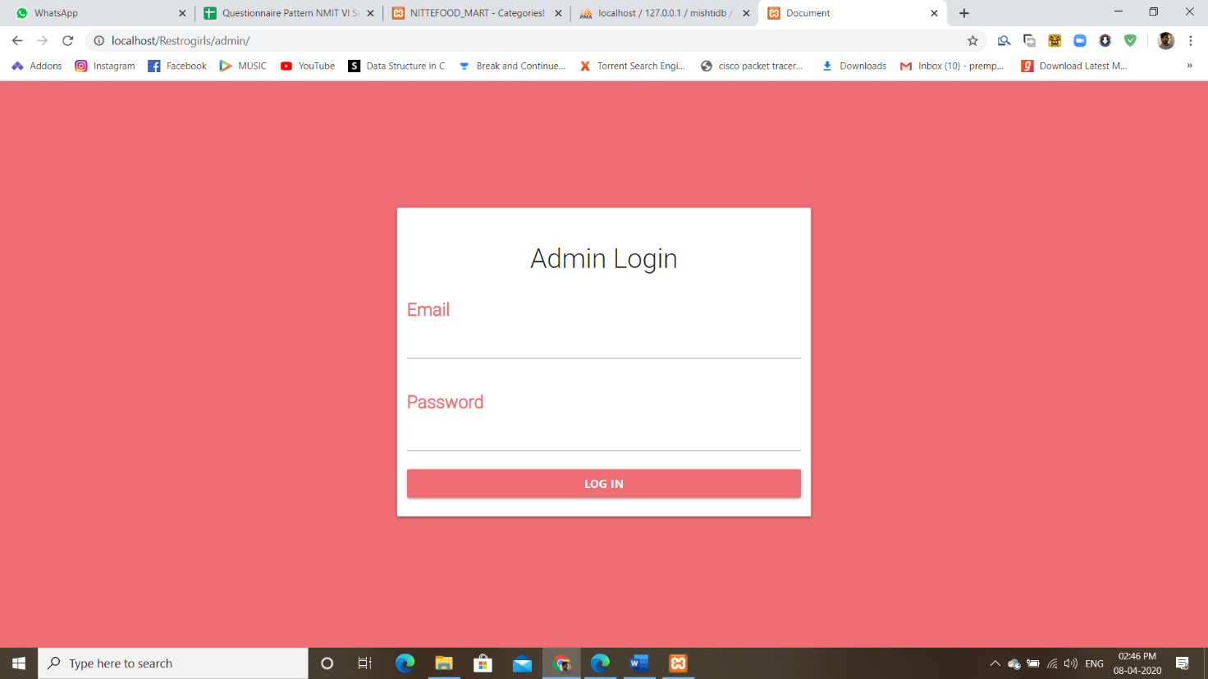

**!!THANK!!**

**!!YOU!!**